CPSC 425 Assignment 5 （due November 14, 2018）

Quan Zhang

48486154

4 Implemented in def build_vocabulary(image_paths, vocab_size) and def get_bags_of_sifts(image_paths, kmeans) in util.py

5 Implemented in def nearest_neighbor_classify(train_image_feats, train_labels, test_image_feats) and def svm_classify(train_image_feats, train_labels, test_image_feats) in classifiers.py

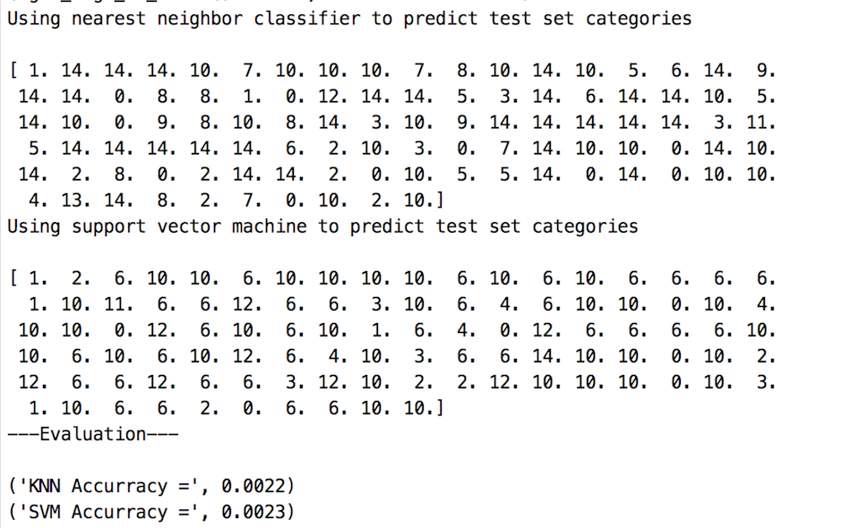

figure 5

The best KNN Accuracy I get is 0.0023 and the best SVM Accuracy I get 0.0023, not very successful.

Confusion matrix:

